**Job Satisfaction in Higher Education**

Josh and Ha

**Introduction**

Job satisfaction, defined as how content an employee is with his or her job, is an important tool for managers to assess their work environment. Employers should understand and improve their employees’ level of job satisfaction in order to boost motivation and productivity at work, as well as attract prospective candidates for their companies. But what factors influence how an individual rates job satisfaction? External elements such as income, location, and benefits could be the main determinants for some, whereas others might require self-fulfillment, achievements, and relationships.

Previous literature points out that some aspects of job satisfaction are beyond employers’ control. Johnson et al. (2005) uses the ASSET stress questionnaire to examine the physical health, psychological well-being and job satisfaction of 25000 individuals in the UK across a wider range of occupations. The results indicate that physical health and psychological well-being are highly correlated with job satisfaction. Occupations with the lowest job satisfaction include prison officer, ambulance and police, and those with highest job satisfaction are director (private sector), analyst and accountant. Interestingly, people with different jobs within a field experience different level of satisfaction. For example, senior police officers report less stress and higher satisfaction compared to junior police officers. Johnson et al. (2005) proposes that this observed difference could be due to the different level of emotional labor they experience.

However, even with aspects that are within employers’ control such as salary, their influence on job satisfaction is complicated. Tang et al. (1995) shows that dissatisfaction may be caused by certain negative attitudes towards money, and not money itself. For example, those who can budget and believe money is good tend to have less stress and receive external satisfaction from their job (benefits, pay, etc.). Those who believe money represents freedom and power, tend to not care as much about the physical aspect of money and want require satisfaction from their job (fulfillment in working, positive people to work with, etc.). Thus, Tang et al. (1995) shows that satisfaction is not always related to income level. For example, both individuals who have intrinsic satisfaction and have a high work ethic but low incomes, and individuals who have extrinsic satisfaction and high incomes can similarly experience low satisfaction.

Because of this, we will look beyond occupations or income and explore a variety of factors related to work, demographics, and benefits that may affect job satisfaction. We will look specifically at people with higher levels of education, because this knowledge is helpful for undergraduate students like us. The primary goal of this research project is to understand how job satisfaction differs across occupations and work activities in higher education. We hypothesize that different occupations and work activities are associated with different levels of job satisfaction when other demographic and benefit factors are controlled for.

**Materials and Methods**

Data for this study was collected from the Integrated Public Use Microdata Series (IPUMS) Higher Education website on various aspects of education, work and demographics in 2013. Three surveys on college and doctorate degree recipients living in the US were used: the National Survey of College Graduates (NSCG), the Survey of Doctorate Recipients (SDR), and the National Survey of Recent College Graduates (NSRCG). Job satisfaction of employed participants is the key response variable, which includes four levels: very satisfied, somewhat satisfied, somewhat dissatisfied, and very dissatisfied. Because of the large number of explanatory variables, they were divided into three subgroups of predictors: work (e.g., principal job, primary work activity, and whether the principal job is related to highest degree), benefits (e.g., salary, paid vacation, health insurance), and demographics (e.g., age, gender and race). In regards to data modifications, we excluded individuals who did not rate how satisfied they were with their jobs and worked with only four levels of satisfaction. Age of the subjects was centered at 23 years old and divided by 10 in order to improve interpretability. Job salary was also scaled (subtracting the mean and dividing by its standard deviation) in order to avoid errors from the polr function from the MASS package in R.

Because of the structure of the response variable, ordinal regression was used to compare different levels of job satisfaction (very satisfied, somewhat satisfied, somewhat dissatisfied, and very dissatisfied) with three subgroups of explanatory variables. Using the polr function from the MASS package in R, we modeled the log odds of being in one level of satisfaction (eg: somewhat satisfied - j=2) versus being in levels above it (Somewhat and very dissatisfied - j=3 and 4). Proportional odds model equation:

logit[P(Y≤j)]=αj – βx, j=1,…,J−1

This is why R output gives us three intercepts, which correspond to the 3 levels of job satisfaction (very satisfied, somewhat satisfied and somewhat unsatisfied), and we don’t model the highest category (very unsatisfied). Notice that in the proportional odds model equation, we subtract (rather than add) the slope coefficient β. This means that a negative slope coefficient of a predictor is associated with increased job satisfaction, which is important to keep in mind when we interpret the final model’s coefficients.

With the three subgroups of explanatory variables mentioned above (work, benefits and demographics), three separate ordinal regression models were created with each variable group. The three best models for the three subgroups of variables were chosen based on AIC, BIC and likelihood ratio test. The final model was then created based on significant predictors from the three smaller models.

**Results**

To investigate our research question, performed exploratory analysis was first performed to examine the relationship between job satisfaction and the three groups of explanatory variables (work, benefits and demographics). The results suggest that job satisfaction varies across age groups, gender, and races. Overall, people who are male, older, and White tend to have higher job satisfaction than those who are female, younger and Asians or underrepresented minorities. Having higher salary and available benefits (health insurance, paid vacation, pension plan and profit sharing plan) is associated with increased job satisfaction. Potential work-related predictors of satisfaction include primary work activity, field of major for highest degree, and whether the principle job is related to highest degree in our model. Three ordinal regression models were created to assess 3 subgroups of explanatory variables (work, benefits and demographics).

*Ordinal regression model with work variables*

This model predicts job satisfaction with only work-related factors, including whether principal job is related to highest degree, principal job, and primary work activity. Our analysis indicates that that biological and other life science jobs had lower satisfaction than other occupations, while non-science and engineering-related jobs had the highest satisfaction. Expectedly, having a job not related to a person’s highest degree greatly decreased job satisfaction. Lastly, teaching and research have higher satisfaction than jobs that involve management and administration.

*Ordinal regression model with benefit variables*

The second model investigates the relationship between available benefits and job satisfaction. Four binary and one quantitative variables are included: paid vacation/sick/leave days, insurance plan, pension plan, and profit sharing plan and salary. The results indicate that as annual salary increases, job satisfaction also increases. Pension plan and profit sharing plan are associated with increased satisfaction, while paid vacation and health insurance were associated with decreased satisfaction.

*Ordinal regression model with demographic variables*

The third model examines three demographic predictors: age, gender, and race. This model suggests that as age increases from 23 years old, job satisfaction increases as well. Male and White people, on average, have higher job satisfaction than females and Asian or under-represented minorities.

*Combined model*

From the three smaller models above, we combined them to create the final model with 11 predictors in total (Model 4a). We decided to keep all of the variables from the three smaller models above because they are important to account for when looking at satisfaction. Our final model includes the following predictors:

* Work-related factors (main explanatory variables): principal job, primary work activity, and whether the principal job is related to highest degree
* Job benefits (controlled variables): salary (scaled), paid vacation, health insurance, pension plan and profit sharing plan
* Demographic factors (controlled variables): age (scaled), gender and race

|  |  |  |  |  |  |
| --- | --- | --- | --- | --- | --- |
| Variable | Definition | Estimate | Std. error | t-value | p-value |
| OCEDRLPNot Related | Whether or not principal job is related to highest degree | 0.81067768 | 0.02143414 | 37.8217957 | 0.00E+00 |
| OCEDRLPSomewhat Related | 0.48831103 | 0.01516263 | 32.204914 | 1.51E-227 |
| NOCPRMGComputer and mathematical scientists | Field of highest degree | -0.0054192 | 0.02918396 | -0.1856917 | 8.53E-01 |
| NOCPRMGEngineers | 0.07211289 | 0.02710346 | 2.6606524 | 7.80E-03 |
| NOCPRMGNon-science and engineering occupations | -0.162759 | 0.02629819 | -6.1889794 | 6.06E-10 |
| NOCPRMGPhysical and related scientists | 0.04677846 | 0.03382084 | 1.3831254 | 1.67E-01 |
| NOCPRMGScience and engineering related occupations | -0.1020842 | 0.0266838 | -3.8257008 | 1.30E-04 |
| NOCPRMGSocial and related scientists | -0.0624124 | 0.03181912 | -1.9614759 | 4.98E-02 |
| WAPRSMOther | Primary work activity | -0.0791937 | 0.01724915 | -4.5911636 | 4.41E-06 |
| WAPRSMResearch and Development | -0.1182172 | 0.01881236 | -6.28402 | 3.30E-10 |
| WAPRSMTeaching | -0.0868791 | 0.0227736 | -3.8149033 | 1.36E-04 |
| scale(SALARY) | Annual salary | -0.2920453 | 0.00773352 | -37.763588 | 0.00E+00 |
| JOBVAC1 | Paid vacation | 0.1115595 | 0.02269387 | 4.9158423 | 8.84E-07 |
| JOBINSYes | Health insurance | 0.17166969 | 0.0254907 | 6.7346018 | 1.64E-11 |
| JOBPENS1 | Pension plan | -0.0554085 | 0.01827797 | -3.0314389 | 2.43E-03 |
| JOBPROFTYes | Profit sharing plan | -0.2718649 | 0.01525186 | -17.825039 | 4.52E-71 |
| Age10 | Age | -0.09280833 | 0.00054148 | -17.139642 | 7.51E-66 |
| GENDERMale | Gender | 0.04726621 | 0.01351911 | 3.4962529 | 4.72E-04 |
| RACETHWhite | Race | -0.446503 | 0.01698121 | -26.29395 | 2.25E-152 |
| RACETHUnder-represented minorities | -0.2592574 | 0.02033078 | -12.751963 | 3.04E-37 |
| 1|2* | Intercepts | -0.5355906 | 0.03836173 | -13.961586 | 2.67E-44 |
| 2|3* | 1.95563797 | 0.03904139 | 50.0914073 | 0.00E+00 |
| 3|4* | 3.61862672 | 0.04334074 | 83.4925042 | 0.00E+00 |

*Table 1.* Final model including 11 variables and 3 intercepts (*1|2: Very satisfied compared to others, 2|3: Somewhat satisfied compared to somewhat dissatisfied and very dissatisfied, 3|4: Somewhat dissatisfied compared to very dissatisfied)

Across major fields in higher education, non-science and engineering occupations have the highest odds of being very satisfied with their jobs, while engineers have the lowest odds. In non-science and engineering occupations, the odds of being very satisfied versus being in other three satisfaction levels is 1.18 times higher than that of biological, agricultural and other life scientists, after controlling for other factors (t=-6.19). For biological, agricultural, and other life scientists, the odds of being very satisfied versus being in the other three satisfaction levels is 1.07 times higher that of engineers, after controlling for other factors (t=2.67). As expected, the odds of being very satisfied increases as an individual’s job is more related to their highest degree. For jobs closely related to highest degrees, the odds of being very satisfied versus being in other three satisfaction levels is 2.25 times higher than that of jobs not related to highest degrees, after controlling for other factors (t=37.82). Among all primary work activities, research and development has the highest odds of being very satisfied with their jobs, while management and administration have the lowest odds. The odds of being very satisfied versus being in other three satisfaction levels for research and development is 1.13 times higher than that of management and administration, after controlling for other factors (t=-6.28).

For demographic factors, after accounting for other predictors, the odds of being very satisfied versus being in other three satisfaction levels for females is 1.05 times higher than that for male on average (t=3.50). Every 10 years older is associated with a mean increase of 1.10 times higher in the odds of being very satisfied versus being in other three levels (t=-17.14). Whites have the highest level of job satisfaction: 1.56 times higher in the odds of being very satisfied versus being in other three satisfaction levels compared to the lowest group which is Asians. In terms of available benefits, one standard deviation ($41099.72) increase in annual salary is associated with an expected increase of 1.34 times higher in the odds of being very satisfied versus being in other three levels. Interestingly, while the odds of being very satisfied versus being in other three levels is 1.06 and 1.31 times higher when pension plan (t=-3.03) and profit sharing plan (-17.83) are available, this odds is 1.12 and 1.19 times higher when paid vacation (t=4.92) and health insurance (t=6.73) are not available.

**Discussion**

Using ordinal regression models, our study investigates job satisfaction across occupations and primary work activities in higher education when other factors related to work, demographics, and benefits are taken into account. The results indicate that people who work in non-science and engineering-related fields have the highest satisfaction level, followed by science and engineering-related occupations. However, engineers have the lowest satisfaction. Expectedly, a job that is closely related to an individual's degree major is associated with increased satisfaction. Among four primary work activities, jobs that mainly involve research and development are associated with higher satisfaction than those that involve teaching and management/ administration. In addition to the main findings, the results demonstrate that being White with older age and higher income are associated with increased satisfaction. Interestingly, only having pension plan and profit sharing plan are associated with increased satisfaction, while having paid vacation and health insurance have the opposite effects.

Our findings support the study of Johnson et al. (2005) in that there are different levels of job satisfaction across occupations in higher education even when other factors related to work, demographics and benefits are controlled for. For example, even though people who work in science and engineering related fields have high job satisfaction, engineers have the lowest satisfaction among the seven fields examined. This may imply that there are different fields in higher education are associated with different levels of physical health and psychological well-being. It is interesting to see that when income and other factors are controlled for, teaching and research jobs have higher satisfaction than management and administration. This may be due to the fact that management and administration jobs require more emotional labor as they involve difficult decisions related to distributing salary, hiring and firing employees. Our study does not support Tang et al. (1995) in that people with higher job satisfaction tend to have higher income on average. However, it is possible that salary is not a significant predictor of job satisfaction if attitudes toward salary are included in the model.

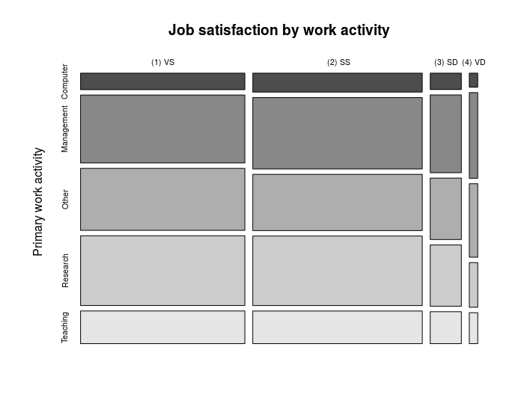

*Figure 1.* Job satisfaction level across primary work activities (VS: very satisfied, SS: somewhat satisfied, SD: somewhat dissatisfied, VD: very dissatisfied)

Though the final model allows us to compare different levels of job satisfaction, there are several limitations. For one, our sample was collected from self-reported satisfaction data, which may lead to survey bias from the responders. Personal traits such as standards for satisfaction were not controlled for in the study. For example, some may find satisfaction from living in a small town and making enough money to earn a living, doing what they love; whereas others may find satisfaction in making a large amount of income. Thirdly, a number of participants in the sample reported $0 for annual salary, which could potentially be due to the fact that they are self-employed or working for non-profit. However, we did not have a good reason to exclude those people or create a separate model for them in our analysis. Lastly, the weight variable was not controlled for, and all weights were assumed to be equal. This may make it hard to generalize our results because it is not representative of the true population who work in higher education in the United States.

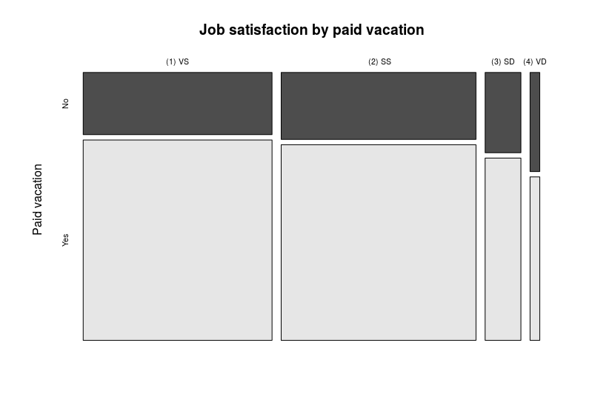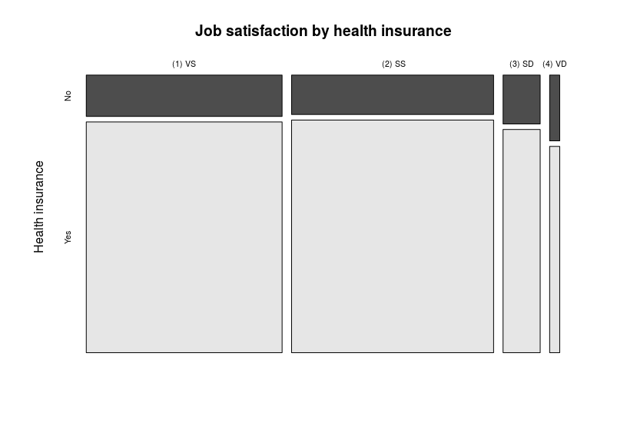

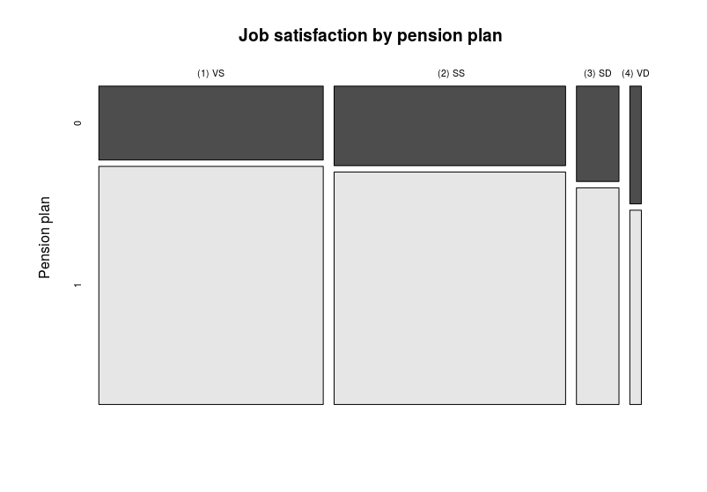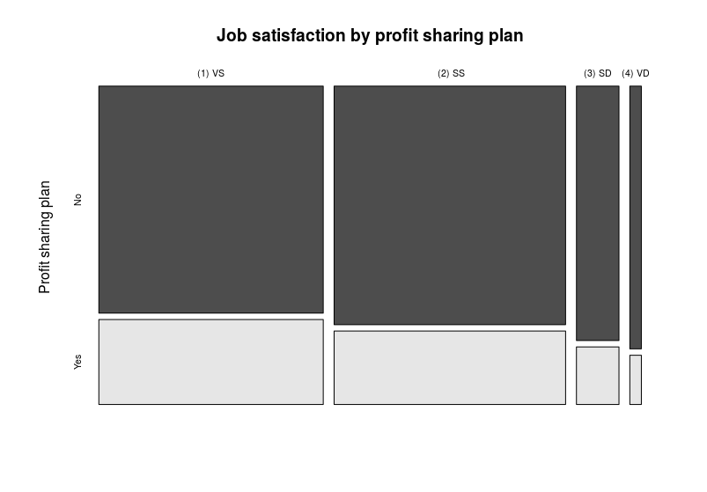

*Figure 2.* Job satisfaction level across four available benefits (VS: very satisfied, SS: somewhat satisfied, SD: somewhat dissatisfied, VD: very dissatisfied)

A number of improvements could also be made to the analysis. For one, using ordinal regression assumes independence among individuals, but there may be correlation among individuals within a one organization or one county. Secondly, the majority of the sample rate themselves as very or somewhat satisfied with their jobs, which leaves the analysis less accurate when comparing somewhat satisfied and the last two levels (somewhat or very dissatisfied). Thirdly, p-values are created by comparing the t-statistics to a normal distribution, which makes them a little lower than they should be. This being said, our ordinal regression model is relatively comprehensive in that a combination of various elements related to work, benefits and demographics are taken into account. Future research can include weight variables in while analyzing the data to attain more accurate results. Lastly, psychological traits could be an important predictor of job satisfaction that we could consider for future steps.

References

Johnson, S., Cooper, C., Cartwright, S., Donald, I., Taylor, P., and Millet, C. (2005). The experience of

work-related stress across occupations. *Journal of Managerial Psychology (20)*, 178-187. doi: 10.1108/02683940510579803. Link: <http://www.lancaster.ac.uk/staff/taylorpj/papers/JMP2005.pdf>

Tang, T. L., and Gilbert, P. R. (1995). Attitudes toward money as related to intrinsic and extrinsic job

satisfaction, stress and work-related attitudes. *Personality and Individual Differences (19)*, 327-332. doi: 10.1016/0191-8869(95)00057-D. Link: <https://www.sciencedirect.com/science/article/pii/019188699500057D>

**Appendix A: Variable chart**

Important variables:

|  |  |  |  |  |  |
| --- | --- | --- | --- | --- | --- |
| Name | Definition | Variable Role | Type | Values | Units |
| PERSONID | Individual ID (only those who are employed) | Observational unit |  |  |  |
| AGE |  | Explanatory | Quantitative | >=19  96 = blank | Years |
| GENDER |  | Explanatory | Categorical | 1 = female  2 = male |  |
| RACETH | Race | Explanatory | Categorical | 1 = Asian  2 = White  3 = Under-represented minorities  4 = Other |  |
| DGRDG | Type of highest degree | Explanatory | Categorical | 1 = bachelor’s  2 = mater’s  3 = doctorate  4 = professional |  |
| HRSWKGR | Principal job: hours per week typically worked (group) | Explanatory | Categorical | 01 = 20 or less  02 = 21 to 35  03 - 36 to 40  04 = greater than 40  98 = logical skip | Hours |
| JOBINS | Available benefits: health insurance | Explanatory | Binary | 00 = no  01 = yes  99 = logical skip |  |
| JOBPENS | Available benefits: pension/retirement plan | Explanatory | Binary | 00 = no  01 = yes  99 = logical skip |  |
| JOBPROFT | Available benefits: profit-sharing plan | Explanatory | Binary | 00 = no  01 = yes  99 = logical skip |  |
| JOBVAC | Available benefits: paid vacation/sick/personal days | Explanatory | Binary | 00 = no  01 = yes  99 = logical skip |  |
| OCEDRLP | Principal job related to highest degree | Explanatory | Categorical | 01 = closely related  02 = somewhat related  03 = not related  98 = logical skip |  |
| NOCPRMG | Job code for principal job (major group) | Explanatory | Categorical | 01 = Computer and mathematical scientists  02 = Biological, agricultural and other life scientists  03 = Physical and related scientists  04 = Social and related scientists  05 = Engineers  06 = Science and engineering related occupations  07 = Non-science and engineering occupations  98 = Logical Skip |  |
| WAPRSM | Summarized primary work activity | Explanatory |  | 1 = research and development  2 = teaching  3 = management and administration  4 = computer applications  5 = other  98 = logical skip |  |
| SALARY | Salary (annualized) | Explanatory | Quantitative | 7-Digit Numeric | Dollar |
| JOBSATIS | Job satisfaction | Repsonse | Ordinal | 01 = very satisfied  02 = somewhat satisfied  03 = somewhat dissatisfied  04 = very dissatisfied  98 = logical skip |  |

**Appendix B: Model building**

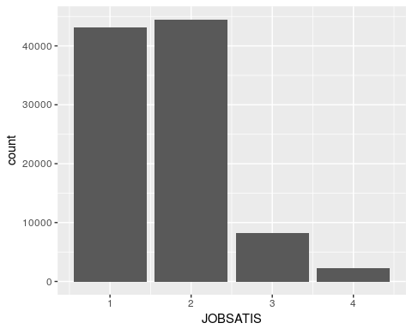

# **Looking at work related factors**

* Intercept: closely related, Biological, agricultural and other life scientists, management and administration All of these variables have significant p-values. -> we include all work-related factors explanatory variables of interest

Model 1

wr1<- **polr**(**as.factor**(JOBSATIS) ~ OCEDRLP + NOCPRMG + WAPRSM, data = ed_data, Hess=TRUE)  
(wr1_ctable <- **coef**(**summary**(wr1)))

## Value Std. Error  
## OCEDRLPNot Related 0.93241420 0.02099290  
## OCEDRLPSomewhat Related 0.49083913 0.01496999  
## NOCPRMGComputer and mathematical scientists -0.06509138 0.02852259  
## NOCPRMGEngineers -0.04690150 0.02635253  
## NOCPRMGNon-science and engineering occupations -0.18720427 0.02584232  
## NOCPRMGPhysical and related scientists -0.03571878 0.03337563  
## NOCPRMGScience and engineering related occupations -0.16811491 0.02629964  
## NOCPRMGSocial and related scientists -0.15713446 0.03124711  
## WAPRSMOther 0.01578719 0.01686006  
## WAPRSMResearch and Development -0.01487528 0.01848314  
## WAPRSMTeaching 0.12467909 0.02156545  
## 1|2 -0.12127609 0.02600874  
## 2|3 2.30017045 0.02742139  
## 3|4 3.94910662 0.03330123  
## t value  
## OCEDRLPNot Related 44.4156937  
## OCEDRLPSomewhat Related 32.7882006  
## NOCPRMGComputer and mathematical scientists -2.2820988  
## NOCPRMGEngineers -1.7797719  
## NOCPRMGNon-science and engineering occupations -7.2440971  
## NOCPRMGPhysical and related scientists -1.0702052  
## NOCPRMGScience and engineering related occupations -6.3922885  
## NOCPRMGSocial and related scientists -5.0287671  
## WAPRSMOther 0.9363662  
## WAPRSMResearch and Development -0.8048026  
## WAPRSMTeaching 5.7814290  
## 1|2 -4.6628976  
## 2|3 83.8823393  
## 3|4 118.5873995

wr1_p <- **pnorm**(**abs**(wr1_ctable[, "t value"]), lower.tail = FALSE) * 2  
(wr1_ctable <- **cbind**(wr1_ctable, "p value" = wr1_p))

## Value Std. Error  
## OCEDRLPNot Related 0.93241420 0.02099290  
## OCEDRLPSomewhat Related 0.49083913 0.01496999  
## NOCPRMGComputer and mathematical scientists -0.06509138 0.02852259  
## NOCPRMGEngineers -0.04690150 0.02635253  
## NOCPRMGNon-science and engineering occupations -0.18720427 0.02584232  
## NOCPRMGPhysical and related scientists -0.03571878 0.03337563  
## NOCPRMGScience and engineering related occupations -0.16811491 0.02629964  
## NOCPRMGSocial and related scientists -0.15713446 0.03124711  
## WAPRSMOther 0.01578719 0.01686006  
## WAPRSMResearch and Development -0.01487528 0.01848314  
## WAPRSMTeaching 0.12467909 0.02156545  
## 1|2 -0.12127609 0.02600874  
## 2|3 2.30017045 0.02742139  
## 3|4 3.94910662 0.03330123  
## t value  
## OCEDRLPNot Related 44.4156937  
## OCEDRLPSomewhat Related 32.7882006  
## NOCPRMGComputer and mathematical scientists -2.2820988  
## NOCPRMGEngineers -1.7797719  
## NOCPRMGNon-science and engineering occupations -7.2440971  
## NOCPRMGPhysical and related scientists -1.0702052  
## NOCPRMGScience and engineering related occupations -6.3922885  
## NOCPRMGSocial and related scientists -5.0287671  
## WAPRSMOther 0.9363662  
## WAPRSMResearch and Development -0.8048026  
## WAPRSMTeaching 5.7814290  
## 1|2 -4.6628976  
## 2|3 83.8823393  
## 3|4 118.5873995  
## p value  
## OCEDRLPNot Related 0.000000e+00  
## OCEDRLPSomewhat Related 8.673272e-236  
## NOCPRMGComputer and mathematical scientists 2.248351e-02  
## NOCPRMGEngineers 7.511330e-02  
## NOCPRMGNon-science and engineering occupations 4.353295e-13  
## NOCPRMGPhysical and related scientists 2.845269e-01  
## NOCPRMGScience and engineering related occupations 1.634212e-10  
## NOCPRMGSocial and related scientists 4.936436e-07  
## WAPRSMOther 3.490847e-01  
## WAPRSMResearch and Development 4.209336e-01  
## WAPRSMTeaching 7.406874e-09  
## 1|2 3.117879e-06  
## 2|3 0.000000e+00  
## 3|4 0.000000e+00

# **Looking at the Available Benefits**

* SALARY gives the model error so we have to scale it
* jb1 includes all job benefits + salary in the model -> we see that all variables significant
* Now we look at interactions: potential interactions from EDA include insurance: pension plan and insurance:paid vacation/sick leave. jb2 includes all job benefits in model + 2 interactions mentioned above -> both interactions are not significant
* Is jb2 (with interaction insurance:vacation) is significantly better than jb1? No, based on LRT test

Model 2a

jb1 <- **polr**(**as.factor**(JOBSATIS) ~ **scale**(SALARY) +JOBVAC + JOBINS + JOBPENS + JOBPROFT, data = ed_data, Hess=TRUE)  
(ctable1 <- **coef**(**summary**(jb1)))

## Value Std. Error t value  
## scale(SALARY) -0.33998890 0.006811173 -49.916353  
## JOBVAC 0.21484302 0.022070344 9.734467  
## JOBINSYes 0.18745527 0.024767927 7.568468  
## JOBPENS1 -0.13685119 0.017891964 -7.648752  
## JOBPROFTYes -0.17408100 0.014801318 -11.761183  
## 1|2 -0.06013167 0.017868646 -3.365206  
## 2|3 2.36403476 0.019868853 118.981943  
## 3|4 4.00963812 0.027363448 146.532635

p1 <- **pnorm**(**abs**(ctable1[, "t value"]), lower.tail = FALSE) * 2  
(ctable1 <- **cbind**(ctable1, "p value" = p1))

## Value Std. Error t value p value  
## scale(SALARY) -0.33998890 0.006811173 -49.916353 0.000000e+00  
## JOBVAC 0.21484302 0.022070344 9.734467 2.149422e-22  
## JOBINSYes 0.18745527 0.024767927 7.568468 3.776505e-14  
## JOBPENS1 -0.13685119 0.017891964 -7.648752 2.029399e-14  
## JOBPROFTYes -0.17408100 0.014801318 -11.761183 6.186169e-32  
## 1|2 -0.06013167 0.017868646 -3.365206 7.648662e-04  
## 2|3 2.36403476 0.019868853 118.981943 0.000000e+00  
## 3|4 4.00963812 0.027363448 146.532635 0.000000e+00

Model 2b

jb2 <- **polr**(**as.factor**(JOBSATIS) ~ **scale**(SALARY) + JOBVAC+ JOBINS + JOBPENS + JOBPROFT + JOBINS:JOBPENS +JOBINS:JOBVAC, data = ed_data, Hess=TRUE)  
(ctable2 <- **coef**(**summary**(jb2)))

## Value Std. Error t value  
## scale(SALARY) -0.33989208 0.006815728 -49.868783  
## JOBVAC 0.26674853 0.040155241 6.642932  
## JOBINSYes 0.20805939 0.033187927 6.269129  
## JOBPENS1 -0.17103284 0.045824711 -3.732328  
## JOBPROFTYes -0.17371095 0.014803604 -11.734369  
## JOBINSYes:JOBPENS1 0.04016511 0.049665339 0.808715  
## JOBVAC:JOBINSYes -0.07312217 0.047960081 -1.524646  
## 1|2 -0.05400841 0.019592481 -2.756588  
## 2|3 2.37021715 0.021449722 110.501066  
## 3|4 4.01583450 0.028531399 140.751406

p2 <- **pnorm**(**abs**(ctable2[, "t value"]), lower.tail = FALSE) * 2  
(ctable2 <- **cbind**(ctable2, "p value" = p2))

## Value Std. Error t value p value  
## scale(SALARY) -0.33989208 0.006815728 -49.868783 0.000000e+00  
## JOBVAC 0.26674853 0.040155241 6.642932 3.075040e-11  
## JOBINSYes 0.20805939 0.033187927 6.269129 3.630739e-10  
## JOBPENS1 -0.17103284 0.045824711 -3.732328 1.897184e-04  
## JOBPROFTYes -0.17371095 0.014803604 -11.734369 8.495752e-32  
## JOBINSYes:JOBPENS1 0.04016511 0.049665339 0.808715 4.186791e-01  
## JOBVAC:JOBINSYes -0.07312217 0.047960081 -1.524646 1.273473e-01  
## 1|2 -0.05400841 0.019592481 -2.756588 5.840783e-03  
## 2|3 2.37021715 0.021449722 110.501066 0.000000e+00  
## 3|4 4.01583450 0.028531399 140.751406 0.000000e+00

**anova**(jb1, jb2)

## Likelihood ratio tests of ordinal regression models  
##   
## Response: as.factor(JOBSATIS)  
## Model  
## 1 scale(SALARY) + JOBVAC + JOBINS + JOBPENS + JOBPROFT  
## 2 scale(SALARY) + JOBVAC + JOBINS + JOBPENS + JOBPROFT + JOBINS:JOBPENS + JOBINS:JOBVAC  
## Resid. df Resid. Dev Test Df LR stat. Pr(Chi)  
## 1 98043 195420.1   
## 2 98041 195417.6 1 vs 2 2 2.490449 0.2878763

#####

Model 2c

jb3 <- **polr**(**as.factor**(JOBSATIS) ~ **scale**(SALARY)+JOBVAC+ JOBINS + JOBPENS + JOBPROFT + **scale**(SALARY):JOBVAC +**scale**(SALARY):JOBINS, data = ed_data, Hess=TRUE)  
**summary**(jb3)

## Call:  
## polr(formula = as.factor(JOBSATIS) ~ scale(SALARY) + JOBVAC +   
## JOBINS + JOBPENS + JOBPROFT + scale(SALARY):JOBVAC + scale(SALARY):JOBINS,   
## data = ed_data, Hess = TRUE)  
##   
## Coefficients:  
## Value Std. Error t value  
## scale(SALARY) -0.41112 0.01640 -25.0741  
## JOBVAC 0.22287 0.02340 9.5226  
## JOBINSYes 0.23352 0.02792 8.3639  
## JOBPENS1 -0.13846 0.01795 -7.7126  
## JOBPROFTYes -0.17635 0.01481 -11.9062  
## scale(SALARY):JOBVAC 0.01693 0.02109 0.8028  
## scale(SALARY):JOBINSYes 0.07052 0.02324 3.0344  
##   
## Intercepts:  
## Value Std. Error t value   
## 1|2 -0.0064 0.0212 -0.2993  
## 2|3 2.4179 0.0229 105.3860  
## 3|4 4.0637 0.0297 136.9287  
##   
## Residual Deviance: 195396.82   
## AIC: 195416.82

**anova**(jb1, jb3)

## Likelihood ratio tests of ordinal regression models  
##   
## Response: as.factor(JOBSATIS)  
## Model  
## 1 scale(SALARY) + JOBVAC + JOBINS + JOBPENS + JOBPROFT  
## 2 scale(SALARY) + JOBVAC + JOBINS + JOBPENS + JOBPROFT + scale(SALARY):JOBVAC + scale(SALARY):JOBINS  
## Resid. df Resid. Dev Test Df LR stat. Pr(Chi)  
## 1 98043 195420.1   
## 2 98041 195396.8 1 vs 2 2 23.31669 8.64661e-06

# **Looking at the Demographic factors**

* dmf1 includes all demographic factors -> all significant

Model 3

dmf1 <- **polr**(**as.factor**(JOBSATIS) ~ Age10 + GENDER +RACETH, data = ed_data, Hess=TRUE)  
**exp**(-0.8476)/(1 +**exp**(-0.8476)) *#Probability of very satisfied for white*

## [1] 0.2999366

(ctable.dmf1 <- **coef**(**summary**(jb1)))

## Value Std. Error t value  
## scale(SALARY) -0.33998890 0.006811173 -49.916353  
## JOBVAC 0.21484302 0.022070344 9.734467  
## JOBINSYes 0.18745527 0.024767927 7.568468  
## JOBPENS1 -0.13685119 0.017891964 -7.648752  
## JOBPROFTYes -0.17408100 0.014801318 -11.761183  
## 1|2 -0.06013167 0.017868646 -3.365206  
## 2|3 2.36403476 0.019868853 118.981943  
## 3|4 4.00963812 0.027363448 146.532635

p.dmf1 <- **pnorm**(**abs**(ctable.dmf1[, "t value"]), lower.tail = FALSE) * 2  
(ctable.dmf1 <- **cbind**(ctable.dmf1, "p value" = p.dmf1))

## Value Std. Error t value p value  
## scale(SALARY) -0.33998890 0.006811173 -49.916353 0.000000e+00  
## JOBVAC 0.21484302 0.022070344 9.734467 2.149422e-22  
## JOBINSYes 0.18745527 0.024767927 7.568468 3.776505e-14  
## JOBPENS1 -0.13685119 0.017891964 -7.648752 2.029399e-14  
## JOBPROFTYes -0.17408100 0.014801318 -11.761183 6.186169e-32  
## 1|2 -0.06013167 0.017868646 -3.365206 7.648662e-04  
## 2|3 2.36403476 0.019868853 118.981943 0.000000e+00  
## 3|4 4.00963812 0.027363448 146.532635 0.000000e+00

# **Combine 3 groups of factors**

* final1 combine the 3 small models above (basically all variables we looked at) -> all significant. One problem is that the model is huge
* One idea for reducing the model: we can look at effect size. Although signifcant, effect size of pension plan, gender and age is small.
* final2 excludes pension plan, gender and age. However, both AIC and LRT favors final1

Model 4a

final1 <- **polr**(**as.factor**(JOBSATIS) ~ OCEDRLP + NOCPRMG + WAPRSM + **scale**(SALARY) +JOBVAC + JOBINS + JOBPENS + JOBPROFT + Age10 + GENDER +RACETH, data = ed_data, Hess=TRUE)  
**exp**(-**coef**(final1))

## OCEDRLPNot Related   
## 0.4445540   
## OCEDRLPSomewhat Related   
## 0.6136610   
## NOCPRMGComputer and mathematical scientists   
## 1.0054330   
## NOCPRMGEngineers   
## 0.9304278   
## NOCPRMGNon-science and engineering occupations   
## 1.1767557   
## NOCPRMGPhysical and related scientists   
## 0.9542942   
## NOCPRMGScience and engineering related occupations   
## 1.1074752   
## NOCPRMGSocial and related scientists   
## 1.0644094   
## WAPRSMOther   
## 1.0824161   
## WAPRSMResearch and Development   
## 1.1254903   
## WAPRSMTeaching   
## 1.0907656   
## scale(SALARY)   
## 1.3391635   
## JOBVAC   
## 0.8944456   
## JOBINSYes   
## 0.8422511   
## JOBPENS1   
## 1.0569721   
## JOBPROFTYes   
## 1.3124139   
## Age10   
## 1.0972514   
## GENDERMale   
## 0.9538338   
## RACETHWhite   
## 1.5628395   
## RACETHUnder-represented minorities   
## 1.2959681

**AIC**(final1)

## [1] 191901

**BIC**(final1)

## [1] 192119.3

(ctable.final1 <- **coef**(**summary**(final1)))

## Value  
## OCEDRLPNot Related 0.810683734  
## OCEDRLPSomewhat Related 0.488312575  
## NOCPRMGComputer and mathematical scientists -0.005418308  
## NOCPRMGEngineers 0.072110820  
## NOCPRMGNon-science and engineering occupations -0.162761281  
## NOCPRMGPhysical and related scientists 0.046783240  
## NOCPRMGScience and engineering related occupations -0.102082847  
## NOCPRMGSocial and related scientists -0.062420120  
## WAPRSMOther -0.079195662  
## WAPRSMResearch and Development -0.118218731  
## WAPRSMTeaching -0.086879823  
## scale(SALARY) -0.292045164  
## JOBVAC 0.111551139  
## JOBINSYes 0.171677122  
## JOBPENS1 -0.055408319  
## JOBPROFTYes -0.271868136  
## Age10 -0.092808330  
## GENDERMale 0.047265827  
## RACETHWhite -0.446504339  
## RACETHUnder-represented minorities -0.259258012  
## 1|2 -0.535596612  
## 2|3 1.955633029  
## 3|4 3.618608734  
## Std. Error  
## OCEDRLPNot Related 0.021434136  
## OCEDRLPSomewhat Related 0.015162625  
## NOCPRMGComputer and mathematical scientists 0.029183962  
## NOCPRMGEngineers 0.027103460  
## NOCPRMGNon-science and engineering occupations 0.026298191  
## NOCPRMGPhysical and related scientists 0.033820836  
## NOCPRMGScience and engineering related occupations 0.026683798  
## NOCPRMGSocial and related scientists 0.031819129  
## WAPRSMOther 0.017249153  
## WAPRSMResearch and Development 0.018812356  
## WAPRSMTeaching 0.022773601  
## scale(SALARY) 0.007733506  
## JOBVAC 0.022693872  
## JOBINSYes 0.025490702  
## JOBPENS1 0.018277970  
## JOBPROFTYes 0.015251858  
## Age10 0.005414549  
## GENDERMale 0.013519107  
## RACETHWhite 0.016981211  
## RACETHUnder-represented minorities 0.020330784  
## 1|2 0.038361673  
## 2|3 0.039041232  
## 3|4 0.043340541  
## t value  
## OCEDRLPNot Related 37.8220857  
## OCEDRLPSomewhat Related 32.2050148  
## NOCPRMGComputer and mathematical scientists -0.1856605  
## NOCPRMGEngineers 2.6605761  
## NOCPRMGNon-science and engineering occupations -6.1890676  
## NOCPRMGPhysical and related scientists 1.3832668  
## NOCPRMGScience and engineering related occupations -3.8256491  
## NOCPRMGSocial and related scientists -1.9617168  
## WAPRSMOther -4.5912783  
## WAPRSMResearch and Development -6.2841003  
## WAPRSMTeaching -3.8149357  
## scale(SALARY) -37.7636189  
## JOBVAC 4.9154741  
## JOBINSYes 6.7348919  
## JOBPENS1 -3.0314263  
## JOBPROFTYes -17.8252474  
## Age10 -17.1405482  
## GENDERMale 3.4962240  
## RACETHWhite -26.2940226  
## RACETHUnder-represented minorities -12.7519930  
## 1|2 -13.9617635  
## 2|3 50.0914787  
## 3|4 83.4924677

p.final1 <- **pnorm**(**abs**(ctable.final1[, "t value"]), lower.tail = FALSE) * 2  
(ctable.final1 <- **cbind**(ctable.final1, "p value" = p.final1))

## Value  
## OCEDRLPNot Related 0.810683734  
## OCEDRLPSomewhat Related 0.488312575  
## NOCPRMGComputer and mathematical scientists -0.005418308  
## NOCPRMGEngineers 0.072110820  
## NOCPRMGNon-science and engineering occupations -0.162761281  
## NOCPRMGPhysical and related scientists 0.046783240  
## NOCPRMGScience and engineering related occupations -0.102082847  
## NOCPRMGSocial and related scientists -0.062420120  
## WAPRSMOther -0.079195662  
## WAPRSMResearch and Development -0.118218731  
## WAPRSMTeaching -0.086879823  
## scale(SALARY) -0.292045164  
## JOBVAC 0.111551139  
## JOBINSYes 0.171677122  
## JOBPENS1 -0.055408319  
## JOBPROFTYes -0.271868136  
## Age10 -0.092808330  
## GENDERMale 0.047265827  
## RACETHWhite -0.446504339  
## RACETHUnder-represented minorities -0.259258012  
## 1|2 -0.535596612  
## 2|3 1.955633029  
## 3|4 3.618608734  
## Std. Error  
## OCEDRLPNot Related 0.021434136  
## OCEDRLPSomewhat Related 0.015162625  
## NOCPRMGComputer and mathematical scientists 0.029183962  
## NOCPRMGEngineers 0.027103460  
## NOCPRMGNon-science and engineering occupations 0.026298191  
## NOCPRMGPhysical and related scientists 0.033820836  
## NOCPRMGScience and engineering related occupations 0.026683798  
## NOCPRMGSocial and related scientists 0.031819129  
## WAPRSMOther 0.017249153  
## WAPRSMResearch and Development 0.018812356  
## WAPRSMTeaching 0.022773601  
## scale(SALARY) 0.007733506  
## JOBVAC 0.022693872  
## JOBINSYes 0.025490702  
## JOBPENS1 0.018277970  
## JOBPROFTYes 0.015251858  
## Age10 0.005414549  
## GENDERMale 0.013519107  
## RACETHWhite 0.016981211  
## RACETHUnder-represented minorities 0.020330784  
## 1|2 0.038361673  
## 2|3 0.039041232  
## 3|4 0.043340541  
## t value  
## OCEDRLPNot Related 37.8220857  
## OCEDRLPSomewhat Related 32.2050148  
## NOCPRMGComputer and mathematical scientists -0.1856605  
## NOCPRMGEngineers 2.6605761  
## NOCPRMGNon-science and engineering occupations -6.1890676  
## NOCPRMGPhysical and related scientists 1.3832668  
## NOCPRMGScience and engineering related occupations -3.8256491  
## NOCPRMGSocial and related scientists -1.9617168  
## WAPRSMOther -4.5912783  
## WAPRSMResearch and Development -6.2841003  
## WAPRSMTeaching -3.8149357  
## scale(SALARY) -37.7636189  
## JOBVAC 4.9154741  
## JOBINSYes 6.7348919  
## JOBPENS1 -3.0314263  
## JOBPROFTYes -17.8252474  
## Age10 -17.1405482  
## GENDERMale 3.4962240  
## RACETHWhite -26.2940226  
## RACETHUnder-represented minorities -12.7519930  
## 1|2 -13.9617635  
## 2|3 50.0914787  
## 3|4 83.4924677  
## p value  
## OCEDRLPNot Related 0.000000e+00  
## OCEDRLPSomewhat Related 1.501481e-227  
## NOCPRMGComputer and mathematical scientists 8.527110e-01  
## NOCPRMGEngineers 7.800709e-03  
## NOCPRMGNon-science and engineering occupations 6.052111e-10  
## NOCPRMGPhysical and related scientists 1.665831e-01  
## NOCPRMGScience and engineering related occupations 1.304280e-04  
## NOCPRMGSocial and related scientists 4.979547e-02  
## WAPRSMOther 4.405395e-06  
## WAPRSMResearch and Development 3.297578e-10  
## WAPRSMTeaching 1.362184e-04  
## scale(SALARY) 0.000000e+00  
## JOBVAC 8.856786e-07  
## JOBINSYes 1.640518e-11  
## JOBPENS1 2.434014e-03  
## JOBPROFTYes 4.500956e-71  
## Age10 7.395017e-66  
## GENDERMale 4.718925e-04  
## RACETHWhite 2.244646e-152  
## RACETHUnder-represented minorities 3.038760e-37  
## 1|2 2.667508e-44  
## 2|3 0.000000e+00  
## 3|4 0.000000e+00

Model 4b

final2 <- **polr**(**as.factor**(JOBSATIS) ~ OCEDRLP + NOCPRMG + WAPRSM + **scale**(SALARY) +JOBVAC + JOBINS + JOBPROFT +RACETH, data = ed_data, Hess=TRUE)  
**AIC**(final2)

## [1] 192207.1

**BIC**(final2)

## [1] 192396.9

(ctable.final2 <- **coef**(**summary**(final2)))

## Value  
## OCEDRLPNot Related 0.79064514  
## OCEDRLPSomewhat Related 0.47753661  
## NOCPRMGComputer and mathematical scientists 0.03632466  
## NOCPRMGEngineers 0.11070406  
## NOCPRMGNon-science and engineering occupations -0.15386409  
## NOCPRMGPhysical and related scientists 0.05197981  
## NOCPRMGScience and engineering related occupations -0.09074124  
## NOCPRMGSocial and related scientists -0.07077733  
## WAPRSMOther -0.07688045  
## WAPRSMResearch and Development -0.10286946  
## WAPRSMTeaching -0.13332424  
## scale(SALARY) -0.33452103  
## JOBVAC 0.12383363  
## JOBINSYes 0.19932594  
## JOBPROFTYes -0.26533222  
## RACETHWhite -0.48512117  
## RACETHUnder-represented minorities -0.27063378  
## 1|2 -0.31285648  
## 2|3 2.17260771  
## 3|4 3.83394023  
## Std. Error t value  
## OCEDRLPNot Related 0.021390215 36.962936  
## OCEDRLPSomewhat Related 0.015130866 31.560428  
## NOCPRMGComputer and mathematical scientists 0.028994570 1.252809  
## NOCPRMGEngineers 0.026831378 4.125918  
## NOCPRMGNon-science and engineering occupations 0.026253681 -5.860667  
## NOCPRMGPhysical and related scientists 0.033721660 1.541437  
## NOCPRMGScience and engineering related occupations 0.026619494 -3.408827  
## NOCPRMGSocial and related scientists 0.031748210 -2.229333  
## WAPRSMOther 0.017231652 -4.461583  
## WAPRSMResearch and Development 0.018769085 -5.480792  
## WAPRSMTeaching 0.022558920 -5.910045  
## scale(SALARY) 0.007119906 -46.983909  
## JOBVAC 0.022105638 5.601903  
## JOBINSYes 0.023860829 8.353689  
## JOBPROFTYes 0.015171760 -17.488559  
## RACETHWhite 0.016806436 -28.865203  
## RACETHUnder-represented minorities 0.020269946 -13.351480  
## 1|2 0.034943605 -8.953183  
## 2|3 0.035855426 60.593554  
## 3|4 0.040525281 94.606135

p.final2 <- **pnorm**(**abs**(ctable.final2[, "t value"]), lower.tail = FALSE) * 2  
(ctable.final2 <- **cbind**(ctable.final1, "p value" = p.final2))

## Value  
## OCEDRLPNot Related 0.810683734  
## OCEDRLPSomewhat Related 0.488312575  
## NOCPRMGComputer and mathematical scientists -0.005418308  
## NOCPRMGEngineers 0.072110820  
## NOCPRMGNon-science and engineering occupations -0.162761281  
## NOCPRMGPhysical and related scientists 0.046783240  
## NOCPRMGScience and engineering related occupations -0.102082847  
## NOCPRMGSocial and related scientists -0.062420120  
## WAPRSMOther -0.079195662  
## WAPRSMResearch and Development -0.118218731  
## WAPRSMTeaching -0.086879823  
## scale(SALARY) -0.292045164  
## JOBVAC 0.111551139  
## JOBINSYes 0.171677122  
## JOBPENS1 -0.055408319  
## JOBPROFTYes -0.271868136  
## Age10 -0.092808330  
## GENDERMale 0.047265827  
## RACETHWhite -0.446504339  
## RACETHUnder-represented minorities -0.259258012  
## 1|2 -0.535596612  
## 2|3 1.955633029  
## 3|4 3.618608734  
## Std. Error  
## OCEDRLPNot Related 0.021434136  
## OCEDRLPSomewhat Related 0.015162625  
## NOCPRMGComputer and mathematical scientists 0.029183962  
## NOCPRMGEngineers 0.027103460  
## NOCPRMGNon-science and engineering occupations 0.026298191  
## NOCPRMGPhysical and related scientists 0.033820836  
## NOCPRMGScience and engineering related occupations 0.026683798  
## NOCPRMGSocial and related scientists 0.031819129  
## WAPRSMOther 0.017249153  
## WAPRSMResearch and Development 0.018812356  
## WAPRSMTeaching 0.022773601  
## scale(SALARY) 0.007733506  
## JOBVAC 0.022693872  
## JOBINSYes 0.025490702  
## JOBPENS1 0.018277970  
## JOBPROFTYes 0.015251858  
## Age10 0.005414549  
## GENDERMale 0.013519107  
## RACETHWhite 0.016981211  
## RACETHUnder-represented minorities 0.020330784  
## 1|2 0.038361673  
## 2|3 0.039041232  
## 3|4 0.043340541  
## t value  
## OCEDRLPNot Related 37.8220857  
## OCEDRLPSomewhat Related 32.2050148  
## NOCPRMGComputer and mathematical scientists -0.1856605  
## NOCPRMGEngineers 2.6605761  
## NOCPRMGNon-science and engineering occupations -6.1890676  
## NOCPRMGPhysical and related scientists 1.3832668  
## NOCPRMGScience and engineering related occupations -3.8256491  
## NOCPRMGSocial and related scientists -1.9617168  
## WAPRSMOther -4.5912783  
## WAPRSMResearch and Development -6.2841003  
## WAPRSMTeaching -3.8149357  
## scale(SALARY) -37.7636189  
## JOBVAC 4.9154741  
## JOBINSYes 6.7348919  
## JOBPENS1 -3.0314263  
## JOBPROFTYes -17.8252474  
## Age10 -17.1405482  
## GENDERMale 3.4962240  
## RACETHWhite -26.2940226  
## RACETHUnder-represented minorities -12.7519930  
## 1|2 -13.9617635  
## 2|3 50.0914787  
## 3|4 83.4924677  
## p value  
## OCEDRLPNot Related 0.000000e+00  
## OCEDRLPSomewhat Related 1.501481e-227  
## NOCPRMGComputer and mathematical scientists 8.527110e-01  
## NOCPRMGEngineers 7.800709e-03  
## NOCPRMGNon-science and engineering occupations 6.052111e-10  
## NOCPRMGPhysical and related scientists 1.665831e-01  
## NOCPRMGScience and engineering related occupations 1.304280e-04  
## NOCPRMGSocial and related scientists 4.979547e-02  
## WAPRSMOther 4.405395e-06  
## WAPRSMResearch and Development 3.297578e-10  
## WAPRSMTeaching 1.362184e-04  
## scale(SALARY) 0.000000e+00  
## JOBVAC 8.856786e-07  
## JOBINSYes 1.640518e-11  
## JOBPENS1 2.434014e-03  
## JOBPROFTYes 4.500956e-71  
## Age10 7.395017e-66  
## GENDERMale 4.718925e-04  
## RACETHWhite 2.244646e-152  
## RACETHUnder-represented minorities 3.038760e-37  
## 1|2 2.667508e-44  
## 2|3 0.000000e+00  
## 3|4 0.000000e+00  
## p value  
## OCEDRLPNot Related 4.514042e-299  
## OCEDRLPSomewhat Related 1.289875e-218  
## NOCPRMGComputer and mathematical scientists 2.102752e-01  
## NOCPRMGEngineers 3.692589e-05  
## NOCPRMGNon-science and engineering occupations 4.610108e-09  
## NOCPRMGPhysical and related scientists 1.232105e-01  
## NOCPRMGScience and engineering related occupations 6.524296e-04  
## NOCPRMGSocial and related scientists 2.579175e-02  
## WAPRSMOther 8.135630e-06  
## WAPRSMResearch and Development 4.234256e-08  
## WAPRSMTeaching 3.420142e-09  
## scale(SALARY) 0.000000e+00  
## JOBVAC 2.120116e-08  
## JOBINSYes 6.616366e-17  
## JOBPENS1 1.751310e-68  
## JOBPROFTYes 3.265718e-183  
## Age10 1.161187e-40  
## GENDERMale 3.453773e-19  
## RACETHWhite 0.000000e+00  
## RACETHUnder-represented minorities 0.000000e+00  
## 1|2 4.514042e-299  
## 2|3 1.289875e-218  
## 3|4 2.102752e-01

**anova**(final1, final2)

## Likelihood ratio tests of ordinal regression models  
##   
## Response: as.factor(JOBSATIS)  
## Model  
## 1 OCEDRLP + NOCPRMG + WAPRSM + scale(SALARY) + JOBVAC + JOBINS + JOBPROFT + RACETH  
## 2 OCEDRLP + NOCPRMG + WAPRSM + scale(SALARY) + JOBVAC + JOBINS + JOBPENS + JOBPROFT + Age10 + GENDER + RACETH  
## Resid. df Resid. Dev Test Df LR stat. Pr(Chi)  
## 1 98031 192167.1   
## 2 98028 191855.0 1 vs 2 3 312.0989 0

Model 4c

final3 <- **polr**(**as.factor**(JOBSATIS) ~ OCEDRLP + NOCPRMG + WAPRSM + **scale**(SALARY) +JOBVAC + JOBINS + JOBPENS + JOBPROFT + Age10 + GENDER +RACETH + GENDER:**scale**(SALARY), data = ed_data, Hess=TRUE)  
**summary**(final3)

## Call:  
## polr(formula = as.factor(JOBSATIS) ~ OCEDRLP + NOCPRMG + WAPRSM +   
## scale(SALARY) + JOBVAC + JOBINS + JOBPENS + JOBPROFT + Age10 +   
## GENDER + RACETH + GENDER:scale(SALARY), data = ed_data, Hess = TRUE)  
##   
## Coefficients:  
## Value Std. Error  
## OCEDRLPNot Related 0.8106694 0.021438  
## OCEDRLPSomewhat Related 0.4883112 0.015163  
## NOCPRMGComputer and mathematical scientists -0.0054299 0.029185  
## NOCPRMGEngineers 0.0720799 0.027114  
## NOCPRMGNon-science and engineering occupations -0.1628091 0.026320  
## NOCPRMGPhysical and related scientists 0.0467738 0.033822  
## NOCPRMGScience and engineering related occupations -0.1021185 0.026696  
## NOCPRMGSocial and related scientists -0.0624284 0.031819  
## WAPRSMOther -0.0792027 0.017250  
## WAPRSMResearch and Development -0.1182319 0.018815  
## WAPRSMTeaching -0.0869101 0.022784  
## scale(SALARY) -0.2924228 0.011583  
## JOBVAC 0.1115620 0.022696  
## JOBINSYes 0.1717187 0.025505  
## JOBPENS1 -0.0553984 0.018280  
## JOBPROFTYes -0.2718817 0.015254  
## Age10 -0.0928071 0.005415  
## GENDERMale 0.0473336 0.013619  
## RACETHWhite -0.4465175 0.016984  
## RACETHUnder-represented minorities -0.2592623 0.020331  
## scale(SALARY):GENDERMale 0.0005937 0.013534  
## t value  
## OCEDRLPNot Related 37.81401  
## OCEDRLPSomewhat Related 32.20482  
## NOCPRMGComputer and mathematical scientists -0.18605  
## NOCPRMGEngineers 2.65836  
## NOCPRMGNon-science and engineering occupations -6.18582  
## NOCPRMGPhysical and related scientists 1.38296  
## NOCPRMGScience and engineering related occupations -3.82517  
## NOCPRMGSocial and related scientists -1.96197  
## WAPRSMOther -4.59157  
## WAPRSMResearch and Development -6.28408  
## WAPRSMTeaching -3.81460  
## scale(SALARY) -25.24577  
## JOBVAC 4.91548  
## JOBINSYes 6.73262  
## JOBPENS1 -3.03059  
## JOBPROFTYes -17.82327  
## Age10 -17.14001  
## GENDERMale 3.47545  
## RACETHWhite -26.28972  
## RACETHUnder-represented minorities -12.75191  
## scale(SALARY):GENDERMale 0.04386  
##   
## Intercepts:  
## Value Std. Error t value   
## 1|2 -0.5355 0.0385 -13.9248  
## 2|3 1.9557 0.0391 49.9736  
## 3|4 3.6187 0.0434 83.3322  
##   
## Residual Deviance: 191854.95   
## AIC: 191902.95

Model 4d

final4 <- **polr**(**as.factor**(JOBSATIS) ~ OCEDRLP + NOCPRMG + WAPRSM + **scale**(SALARY) +JOBVAC + JOBINS + JOBPENS + JOBPROFT + Age10 + GENDER +RACETH + GENDER:**scale**(SALARY), data = ed_data, Hess=TRUE)  
**summary**(final4)

## Call:  
## polr(formula = as.factor(JOBSATIS) ~ OCEDRLP + NOCPRMG + WAPRSM +   
## scale(SALARY) + JOBVAC + JOBINS + JOBPENS + JOBPROFT + Age10 +   
## GENDER + RACETH + GENDER:scale(SALARY), data = ed_data, Hess = TRUE)  
##   
## Coefficients:  
## Value Std. Error  
## OCEDRLPNot Related 0.8106694 0.021438  
## OCEDRLPSomewhat Related 0.4883112 0.015163  
## NOCPRMGComputer and mathematical scientists -0.0054299 0.029185  
## NOCPRMGEngineers 0.0720799 0.027114  
## NOCPRMGNon-science and engineering occupations -0.1628091 0.026320  
## NOCPRMGPhysical and related scientists 0.0467738 0.033822  
## NOCPRMGScience and engineering related occupations -0.1021185 0.026696  
## NOCPRMGSocial and related scientists -0.0624284 0.031819  
## WAPRSMOther -0.0792027 0.017250  
## WAPRSMResearch and Development -0.1182319 0.018815  
## WAPRSMTeaching -0.0869101 0.022784  
## scale(SALARY) -0.2924228 0.011583  
## JOBVAC 0.1115620 0.022696  
## JOBINSYes 0.1717187 0.025505  
## JOBPENS1 -0.0553984 0.018280  
## JOBPROFTYes -0.2718817 0.015254  
## Age10 -0.0928071 0.005415  
## GENDERMale 0.0473336 0.013619  
## RACETHWhite -0.4465175 0.016984  
## RACETHUnder-represented minorities -0.2592623 0.020331  
## scale(SALARY):GENDERMale 0.0005937 0.013534  
## t value  
## OCEDRLPNot Related 37.81401  
## OCEDRLPSomewhat Related 32.20482  
## NOCPRMGComputer and mathematical scientists -0.18605  
## NOCPRMGEngineers 2.65836  
## NOCPRMGNon-science and engineering occupations -6.18582  
## NOCPRMGPhysical and related scientists 1.38296  
## NOCPRMGScience and engineering related occupations -3.82517  
## NOCPRMGSocial and related scientists -1.96197  
## WAPRSMOther -4.59157  
## WAPRSMResearch and Development -6.28408  
## WAPRSMTeaching -3.81460  
## scale(SALARY) -25.24577  
## JOBVAC 4.91548  
## JOBINSYes 6.73262  
## JOBPENS1 -3.03059  
## JOBPROFTYes -17.82327  
## Age10 -17.14001  
## GENDERMale 3.47545  
## RACETHWhite -26.28972  
## RACETHUnder-represented minorities -12.75191  
## scale(SALARY):GENDERMale 0.04386  
##   
## Intercepts:  
## Value Std. Error t value   
## 1|2 -0.5355 0.0385 -13.9248  
## 2|3 1.9557 0.0391 49.9736  
## 3|4 3.6187 0.0434 83.3322  
##   
## Residual Deviance: 191854.95   
## AIC: 191902.95

Model 4e

final5 <- **polr**(**as.factor**(JOBSATIS) ~ OCEDRLP + NOCPRMG + WAPRSM + **scale**(SALARY) +JOBVAC + JOBINS + JOBPENS + JOBPROFT + Age10 + GENDER +RACETH, data = ed_data, Hess=TRUE)  
**summary**(final5)

## Call:  
## polr(formula = as.factor(JOBSATIS) ~ OCEDRLP + NOCPRMG + WAPRSM +   
## scale(SALARY) + JOBVAC + JOBINS + JOBPENS + JOBPROFT + Age10 +   
## GENDER + RACETH, data = ed_data, Hess = TRUE)  
##   
## Coefficients:  
## Value Std. Error  
## OCEDRLPNot Related 0.810684 0.021434  
## OCEDRLPSomewhat Related 0.488313 0.015163  
## NOCPRMGComputer and mathematical scientists -0.005418 0.029184  
## NOCPRMGEngineers 0.072111 0.027103  
## NOCPRMGNon-science and engineering occupations -0.162761 0.026298  
## NOCPRMGPhysical and related scientists 0.046783 0.033821  
## NOCPRMGScience and engineering related occupations -0.102083 0.026684  
## NOCPRMGSocial and related scientists -0.062420 0.031819  
## WAPRSMOther -0.079196 0.017249  
## WAPRSMResearch and Development -0.118219 0.018812  
## WAPRSMTeaching -0.086880 0.022774  
## scale(SALARY) -0.292045 0.007734  
## JOBVAC 0.111551 0.022694  
## JOBINSYes 0.171677 0.025491  
## JOBPENS1 -0.055408 0.018278  
## JOBPROFTYes -0.271868 0.015252  
## Age10 -0.092808 0.005415  
## GENDERMale 0.047266 0.013519  
## RACETHWhite -0.446504 0.016981  
## RACETHUnder-represented minorities -0.259258 0.020331  
## t value  
## OCEDRLPNot Related 37.8221  
## OCEDRLPSomewhat Related 32.2050  
## NOCPRMGComputer and mathematical scientists -0.1857  
## NOCPRMGEngineers 2.6606  
## NOCPRMGNon-science and engineering occupations -6.1891  
## NOCPRMGPhysical and related scientists 1.3833  
## NOCPRMGScience and engineering related occupations -3.8256  
## NOCPRMGSocial and related scientists -1.9617  
## WAPRSMOther -4.5913  
## WAPRSMResearch and Development -6.2841  
## WAPRSMTeaching -3.8149  
## scale(SALARY) -37.7636  
## JOBVAC 4.9155  
## JOBINSYes 6.7349  
## JOBPENS1 -3.0314  
## JOBPROFTYes -17.8252  
## Age10 -17.1405  
## GENDERMale 3.4962  
## RACETHWhite -26.2940  
## RACETHUnder-represented minorities -12.7520  
##   
## Intercepts:  
## Value Std. Error t value   
## 1|2 -0.5356 0.0384 -13.9618  
## 2|3 1.9556 0.0390 50.0915  
## 3|4 3.6186 0.0433 83.4925  
##   
## Residual Deviance: 191854.95   
## AIC: 191900.95

Model 4f

ed_data_salary <- ed_data[ed_data$SALARY!=0,]  
final6 <- **polr**(**as.factor**(JOBSATIS) ~ OCEDRLP + NOCPRMG + WAPRSM + **scale**(SALARY) +JOBVAC + JOBINS + JOBPENS + JOBPROFT + Age10 + GENDER +RACETH, data = ed_data_salary, Hess=TRUE)  
**summary**(final6)

## Call:  
## polr(formula = as.factor(JOBSATIS) ~ OCEDRLP + NOCPRMG + WAPRSM +   
## scale(SALARY) + JOBVAC + JOBINS + JOBPENS + JOBPROFT + Age10 +   
## GENDER + RACETH, data = ed_data_salary, Hess = TRUE)  
##   
## Coefficients:  
## Value Std. Error  
## OCEDRLPNot Related 0.81296 0.021562  
## OCEDRLPSomewhat Related 0.48905 0.015214  
## NOCPRMGComputer and mathematical scientists -0.00215 0.029251  
## NOCPRMGEngineers 0.07443 0.027147  
## NOCPRMGNon-science and engineering occupations -0.15852 0.026366  
## NOCPRMGPhysical and related scientists 0.04885 0.033870  
## NOCPRMGScience and engineering related occupations -0.09871 0.026741  
## NOCPRMGSocial and related scientists -0.05933 0.031890  
## WAPRSMOther -0.07959 0.017320  
## WAPRSMResearch and Development -0.11755 0.018873  
## WAPRSMTeaching -0.09059 0.022872  
## scale(SALARY) -0.29421 0.007749  
## JOBVAC 0.11036 0.022800  
## JOBINSYes 0.17109 0.025633  
## JOBPENS1 -0.05697 0.018323  
## JOBPROFTYes -0.26924 0.015289  
## Age10 -0.09164 0.005449  
## GENDERMale 0.04985 0.013571  
## RACETHWhite -0.44930 0.017037  
## RACETHUnder-represented minorities -0.26096 0.020402  
## t value  
## OCEDRLPNot Related 37.7033  
## OCEDRLPSomewhat Related 32.1450  
## NOCPRMGComputer and mathematical scientists -0.0735  
## NOCPRMGEngineers 2.7418  
## NOCPRMGNon-science and engineering occupations -6.0121  
## NOCPRMGPhysical and related scientists 1.4422  
## NOCPRMGScience and engineering related occupations -3.6913  
## NOCPRMGSocial and related scientists -1.8603  
## WAPRSMOther -4.5956  
## WAPRSMResearch and Development -6.2283  
## WAPRSMTeaching -3.9608  
## scale(SALARY) -37.9681  
## JOBVAC 4.8404  
## JOBINSYes 6.6747  
## JOBPENS1 -3.1092  
## JOBPROFTYes -17.6103  
## Age10 -16.8163  
## GENDERMale 3.6730  
## RACETHWhite -26.3719  
## RACETHUnder-represented minorities -12.7911  
##   
## Intercepts:  
## Value Std. Error t value   
## 1|2 -0.5321 0.0385 -13.8065  
## 2|3 1.9642 0.0392 50.0753  
## 3|4 3.6342 0.0436 83.3850  
##   
## Residual Deviance: 190416.27   
## AIC: 190462.27